Board of Trustees Policy: The Relationship between the Board and the Principal (NAG 6)

Blind & Low Vision Education Network NZ

The performance of the Blind & Low Vision Education Network NZ (BLENNZ) depends significantly on the effectiveness of this relationship and as such a positive, productive working relationship must be developed and maintained. The Board and the Principal form the leadership team and as such clear role definitions have been developed. The Responsibilities of the Principal and Responsibilities of the Board policies along with the Board’s agreed Code of Conduct should be read alongside this policy.

1. This relationship is based on mutual respect, trust, integrity and ability.
2. The relationship must be professional.
3. The Principal reports to the Board as a whole rather than to individual trustees.
4. Day to day relationships between the Board and the Principal are delegated to the Chair.
5. In exceptional circumstances and with the knowledge of the Principal, the Board may request reports directly from the staff; these reports may come to the Board without the Principal’s approval, but the Principal will be informed that these reports have been requested and received.

6. There are clear delegations and accountabilities by the Board to the Principal through policy.

7. The Board and Principal must work as a team and there should be no surprises.
8. Neither party will deliberately hold back important information.
9. Neither party will knowingly misinform the other.
10. The Board must maintain independence from the Principal in order to fulfil their role. The Board is there to critique and challenge the information that comes to it, acting in the best interests of the BLENNZ students.

11. The Principal should be able to share their professional concerns with the Board.
12. Where there is a problem in the working relationship between the Principal and the Board (or individual member of the Board) that has not been informally resolved and is to the detriment of the school; the Board may, in consultation with the Principal, consider appointing a suitably qualified independent person to mediate or facilitate between the parties and/or undertake an impartial and objective assessment of the concerns raised. The Principal can also suggest to the Board that this occur and in good faith the Board will give due consideration to that request.
Review Schedule: Triennially
Approved: 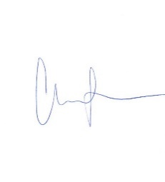
Date: 28 October 2022
Next Review: 2025

